Penguin Feeding Experience  Booking Form | 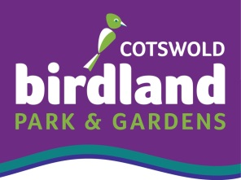
To book just complete this form and post with a cheque for £45 made payable to Birdland Park Ltd. The £45 fee is for one person and includes a full day entrance ticket, penguin feeding experience and certificate. Full details on the schedule for the afternoon, will be confirmed as soon as possible.

Contact Name & Address. | Name of the Person who is booking the experience.
Telephone
Email
Preferred Date | Date is not guaranteed until confirmed.
Is a Gift Token Required? | Please advise what occasion – Christmas / Birthday etc.
Name of Penguin Feeder if different | Please advise name of the actual Penguin Feeder / Gift Recipient
Address if different
Telephone
Email

Cancellation
- Once the date has been confirmed, the minimum cancellation notice is 24 hours and there will be a £10 charge to re-book. Less than 24 hours will be at the discretion of the Manager.

Agreed and Signed By: Date:
Name in Capitals

Further Information:
- Friends and Family are very welcome to accompany and watch the penguin feeding display and will be charged the standard admission price.
- Telephone: 01451 820480
- Email: info@birdland.co.uk
- Find us at: Birdland, Rissington Road, Bourton-on-the-Water, Gloucester, GL54 2BN

Visit: www.birdland.co.uk

